# **Free Chlorine Estimator for Dichlor and Trichlor Systems (FCEDTS) Deployment Instructions**

## Deployment prerequisites

* Cloud.gov access and specifically ***epa-rshiny*** organization deployment permissions.
* Cloud Foundry Command Line Interface (cf [CLI](https://docs.cloudfoundry.org/cf-cli/install-go-cli.html))
* A web browser with internet access

## Deployment steps

1. Download the latest FCEDTS release from GitHub as a zipped file from:

<https://github.com/USEPA/Free-Chlorine-Estimator-for-Dichlor-and-Trichlor-Systems/archive/master.zip>

1. Unzip the FCEDTS release file.
2. Using the command line, navigate to the unzipped FCEDTS location. The contents of the folder should look like:

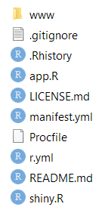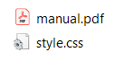

1. Use the cf CLI to log in to Cloud.gov and to the ***epa-rshiny*** organization and to the ***fcedts-prod*** space.
   * + - cf login -a api.fr.cloud.gov --sso
       - cf target -o epa-rshiny -s fcedts-prod
2. Deploy the application to Cloud.gov using the CLI.
   * + - cf push
3. Verify application deployment using the CLI.
   * + - cf app fcedts
4. Notify the customer that the application has been deployed.